Software engineering for big data analaysis

CSA-1035

EXP NO: 21

21. Design an activity diagram for an automated online banking system which shows the flow of type of account, withdrawal, deposit, balance enquiry and check whether the person has a loan. If there is a due in loan then push the notification “pay the due amount

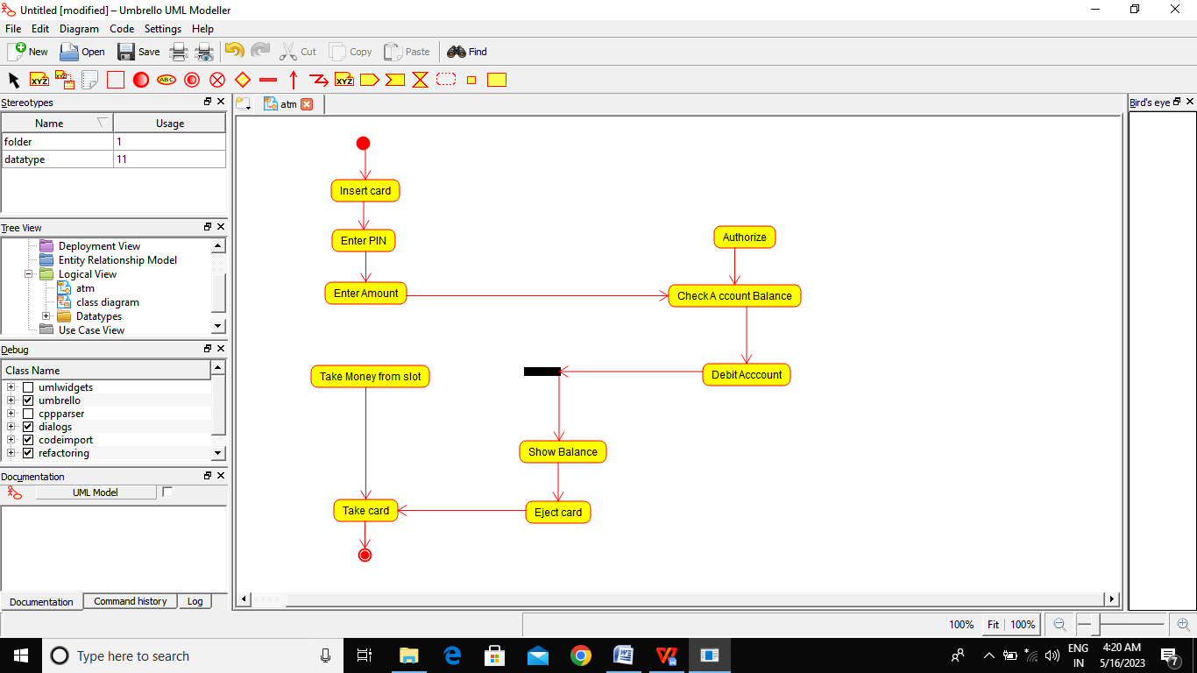

Result:-

Thus the activity daigram for ATM is drawn and verified successfully